# Lesson 08 – AJAX, PHP, MySQL

# Session 1 Worksheet

# Setup

1. Download *C273_L08Ajax.zip* from LEO. Save and extract it to C:\xampp\htdocs\C273_L08Ajax\.
2. Start NetBeans. Create a PHP Project with Existing Source that points to above folder.
3. Start the XAMPP Control Panel, and **start both the Apache and MySQL component**.
4. Type <http://localhost/phpmyadmin> on your browser to open PHPMyAdmin.
5. Create database **c273_p08**. Import the file **c273_p08.sql** into that database. You should have the following tables:

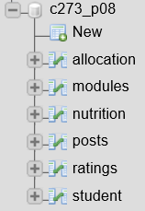

## Recap PHP Webservice

* Create a new PHP file called **getNutrition.php** that retrieves all the data from the **nutrition** table. The GET request: <http://localhost/C273_L08Ajax/getNutrition.php> generates the following JSON response:

|  |
| --- |
| [{"id":"1","food":"Pecans","calories":"691","fat":"72","protein":"9","carbs":"14","fiber":"10"},{"id":"2","food":"Walnuts","calories":"654","fat":"65","protein":"15","carbs":"14","fiber":"7"},{"id":"3","food":"Hazelnuts","calories":"628","fat":"61","protein":"15","carbs":"17","fiber":"10"},{"id":"4","food":"Sunflower Seeds","calories":"584","fat":"51","protein":"21","carbs":"20","fiber":"9"},{..}..] |

* Create a new PHP file called **getNutritionByFood.php** that retrieves the data of a particular food from the **nutrition** table. The GET request: <http://localhost/C273_L08Ajax/getNutritionByFood.php?food=Pecans> generates the following JSON response:

|  |
| --- |
| {"id":"1","food":"Pecans","calories":"691","fat":"72","protein":"9","carbs":"14","fiber":"10"} |

## Exercise 1a:

Go to <http://localhost/C273_L08Ajax/getStudents.php> from the browser to see the JSON message below:

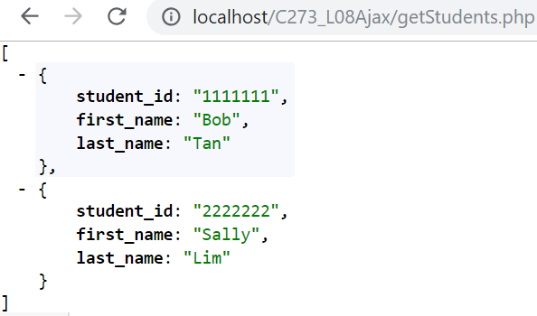

JSON message has [] when there are multiple records from database

Open **1a_showStudentsInTable.html** and see how the jQuery code makes an ajax call to getStudents.php to retrieve all student records and display them in a table.

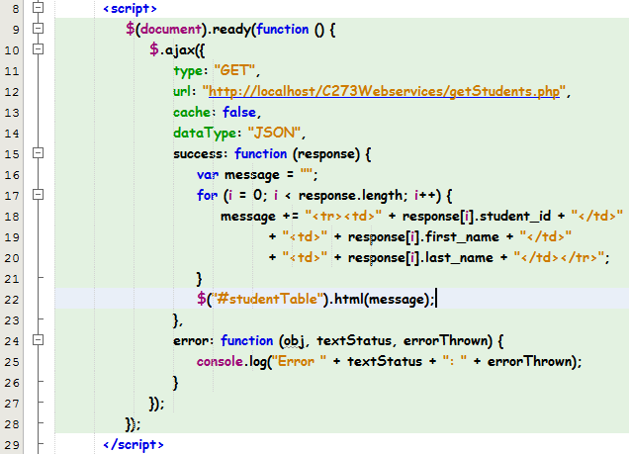

Line 16-20 – In this case the JSON response is an array, thus a for loop is needed to iterate the records. The attributes of response[i] follows that in the JSON message returned by getStudents.php that is student_id, first_name and last_name. The data is set to the table element of id "studentTable"

Run **1a_showStudentsInTable.html** and you should see the student records displayed in the table on the browser.

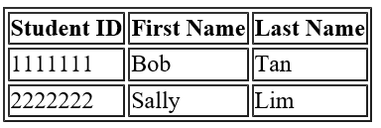

## Exercise 1b:

Go to <http://localhost/C273_L08Ajax/getModules.php> from the browser to see the JSON message

Open the file **1b_showModulesInTable.html**.

Type your jQuery code within the <script> element:

1. Use AJAX to initiate a GET request to **getModules.php**
2. Iterate response array in a for loop
3. Retrieve data from each object and append into **<tr>** element of table id “moduleTable”.

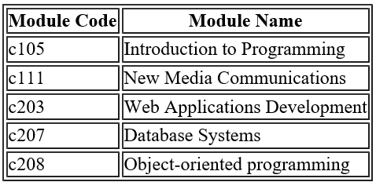

**Challenge**: Enhance it into a Bootstrap Table

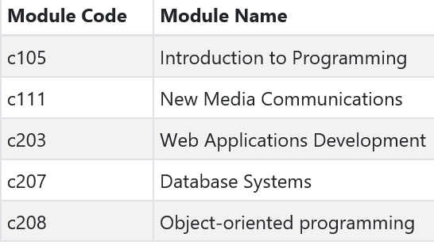

## Exercise 1c:

Open the file **1c_showModulesInSelectList.html**.

Type your jQuery code within the <script> element:

1. Use AJAX to initiate a GET request to **getModules.php**
2. Iterate response array in a for loop
3. Retrieve data from each object and append into **<option>** element of **<select>** id “idModule”.

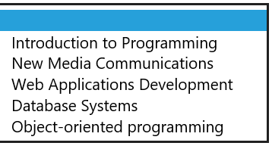

## Exercise 1d

Go to <http://localhost/C273_L08Ajax/getNutrition.php> from the browser to see the JSON message

Open the file **1d_showNutritionInAccordion.html**.

Type your jQuery code within the <script> element:

1. Use AJAX to initiate a GET request to **getNutrition.php**
2. Iterate response array in a for loop
3. Retrieve data from each object and display in an Accordion widget from jQuery UI <https://jqueryui.com/accordion/>

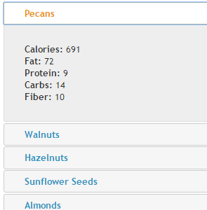

## Exercise 2a:

Go to <http://localhost/C273_L08Ajax/getStudentsByModule.php?module_code=c207> from the browser to see the JSON message below:

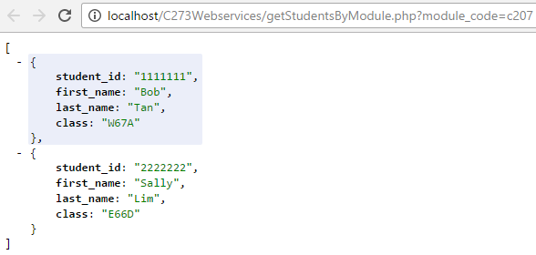

2 student records taking the module code “c207” are retrieved.

Open **2a_showStudentsInTable.html** and type the jQuery code below:

Hint: You can use the code from 1a_showStudentsInTable.html as a base.

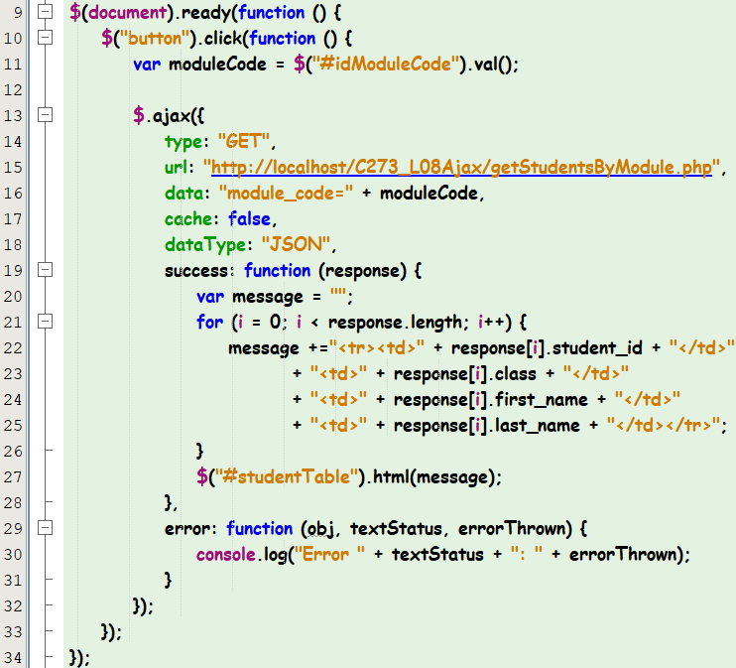

Line 10 – The click listener event is created for button elements

Line 11 – The form field value in element with id "idModuleCode" is retrieved and stored in the variable "moduleCode"

Line 16 - set the “data” parameter in $.ajax method to retrieve specific student records based on the entered module code

Run **2a_showStudentsInTable.html**, enter a module code and click on the "Search" button and you should see the student records displayed in the table on the browser.

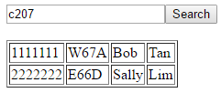

## Exercise 2b:

Open the file **2b_searchStudentDetails.php**.

Type your jQuery code within the <script> element:

1. Detect change event
2. Retrieve value from dropdown list “idStudent”
3. Use AJAX to initiate a GET request to **getStudentDetails.php,** set parameter “student_id” with value from Step 2
4. Display the student details.

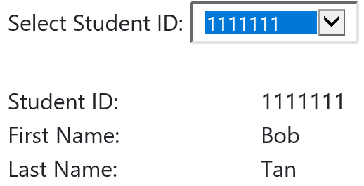

## Exercise 2c

Open **2c_searchStudentsByModule.php** and write the code to do the following:

* A list of modules is displayed in the first dropdown list. (Use PHP)
* Users can select the module and the list of student IDs are populated in the second dropdown list (Use jQuery AJAX)
* User selects the student ID from the second dropdown list and the student details will be displayed as shown below (Use jQuery AJAX):

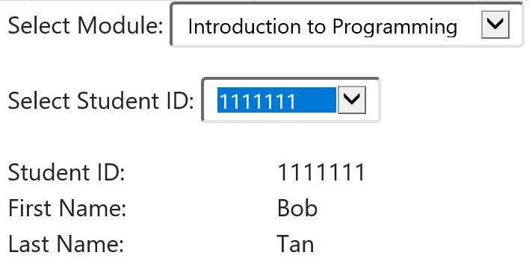

## Exercise 2d

Open **2d_searchNutrition.html.** Write the jQuery code that makes an AJAX call to getNutrition.php to retrieve all records from the nutrition database table and displays the JSON response in an Autocomplete widget from jQuery UI <https://jqueryui.com/autocomplete/>

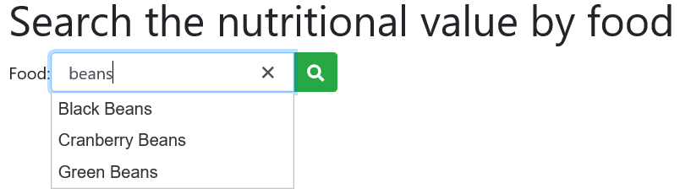

Upon selecting the food and clicking on the [**Search**] button, another AJAX call is made to **getNutritionByFood.php** and retrieves the nutrition record based on the food name. The JSON response is formatted and displayed below:

